1. Line Chart – Daily Page Views
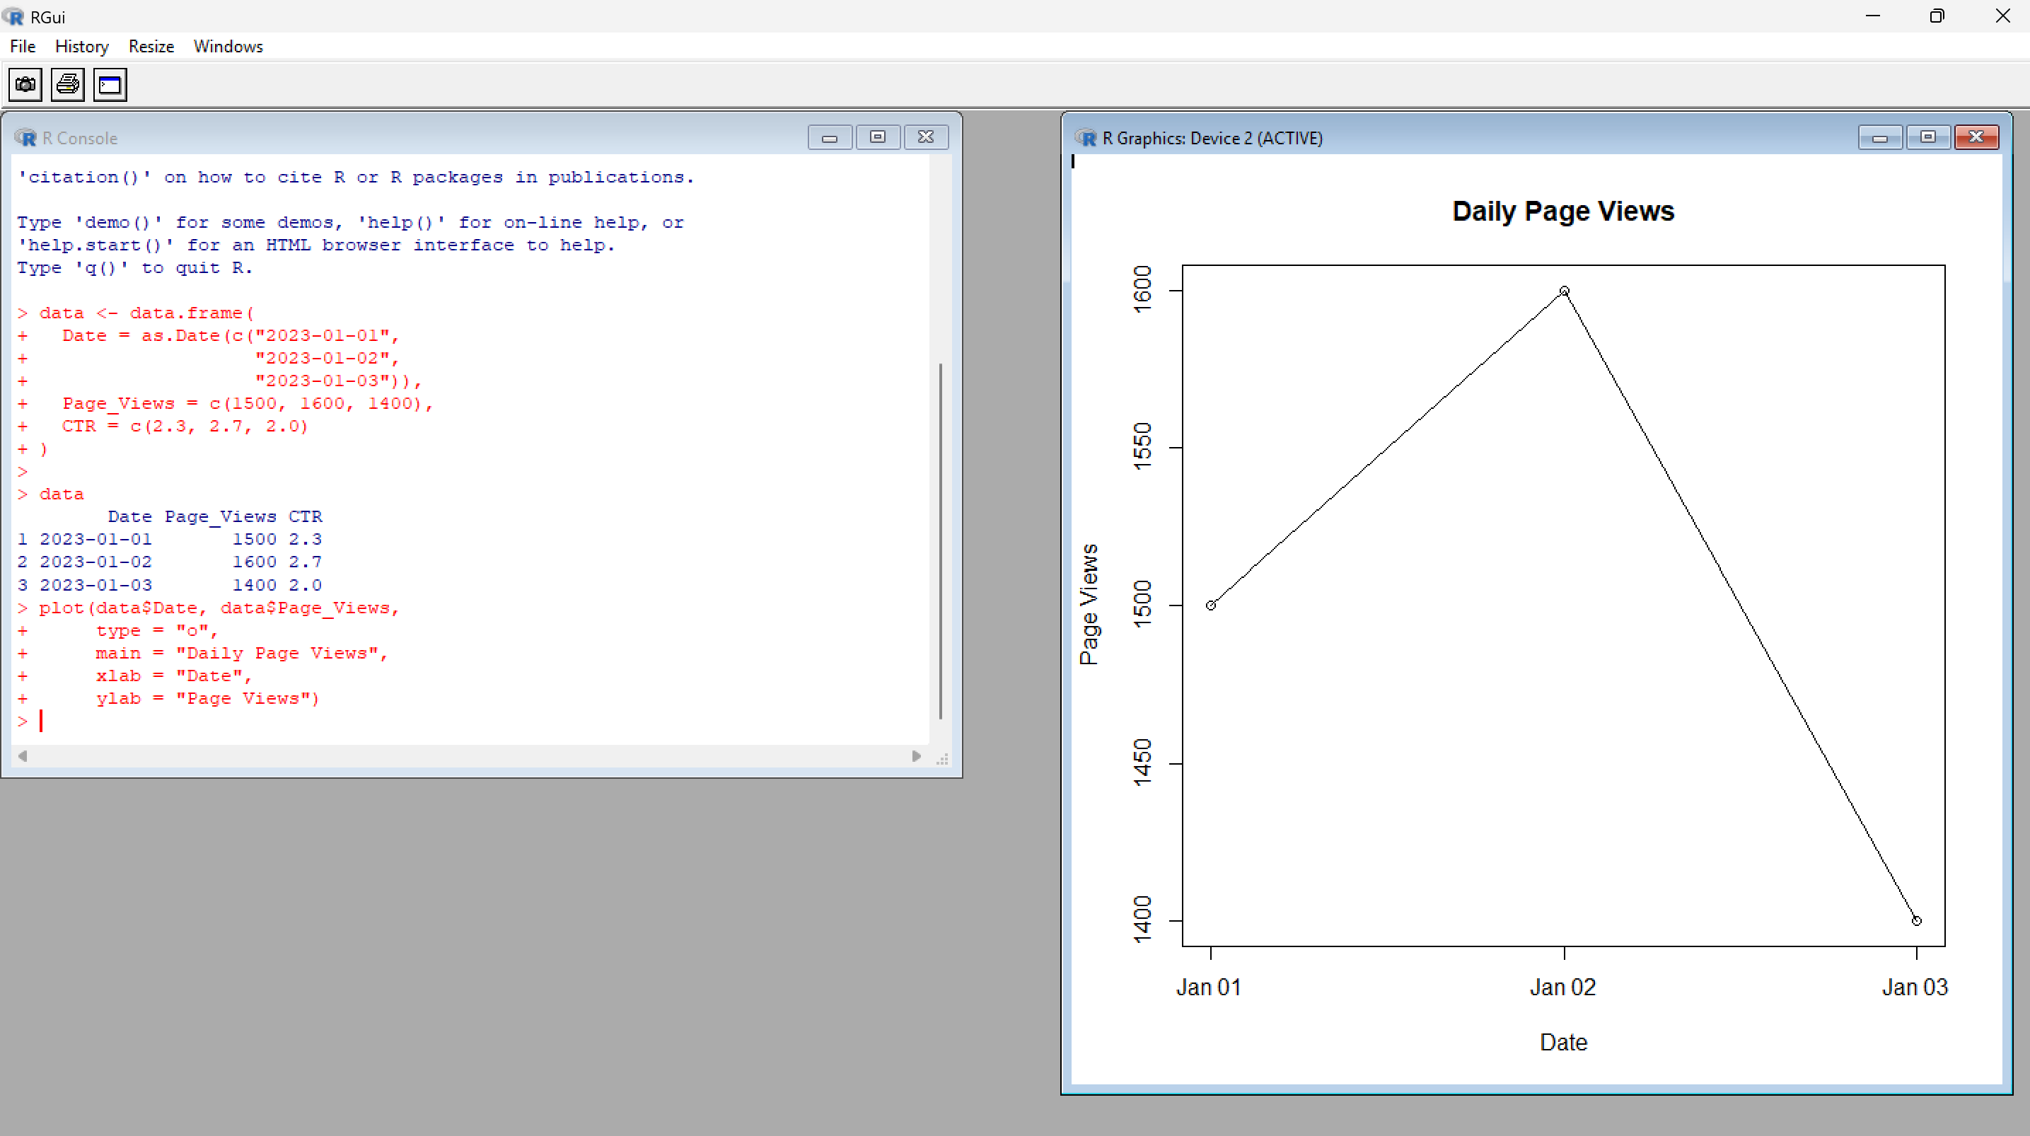
2. Bar Chart – Top N Click-through Rates
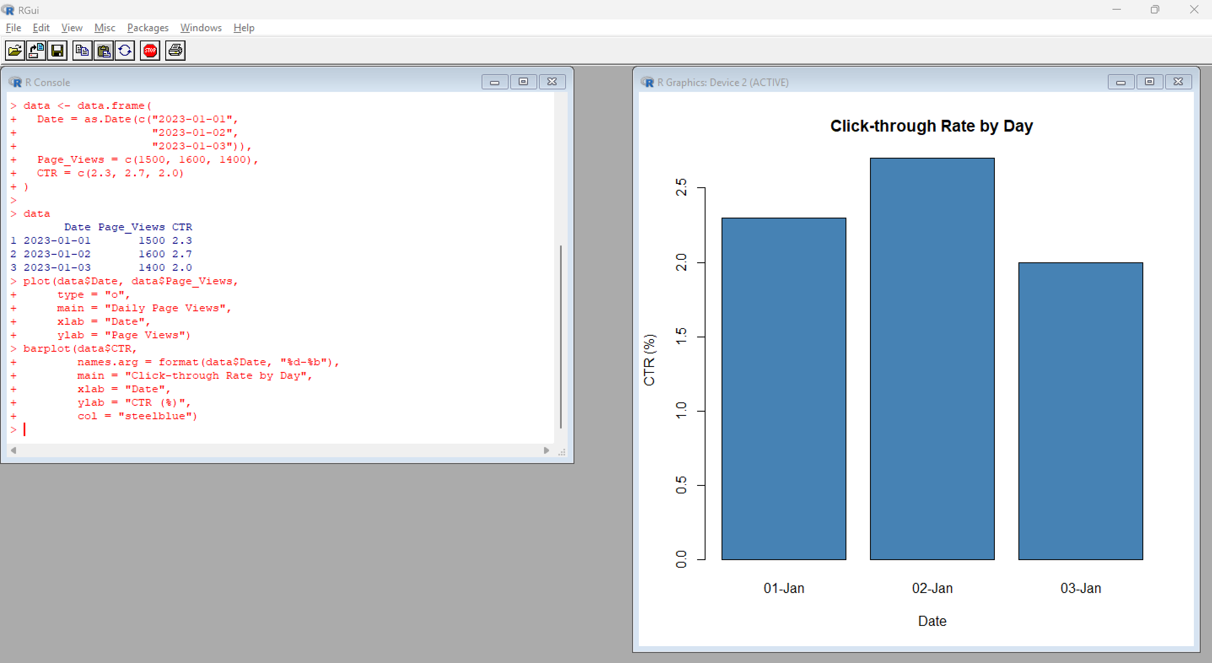

3. Table – Website Traffic
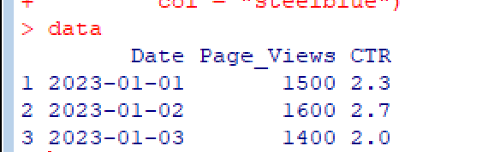
4. Tableau Dashboard
